Notes for use: No more than 50 words per article. Include links, bolding, underline, etc. for easy skimming and readability. This is meant to be short bits of important information.

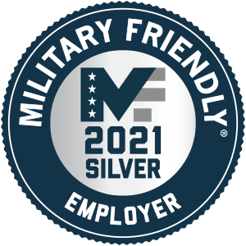
 Congratulations to X! |  | October 2020
- In this Newsletter  - X Named 2021 Military Friendly Employer  - Save the Date | Annual Signature Event  - Employee Deployment News  - Fort Jackson Pen Pals | Reminder to Log Your Hours  - X Salutes Soldier  Join Operation VET   Follow us on Yammer  Operation VET on Shield Central |  | - Calendar  Operation: Got Your Six  Virtual Signature Event  Friday, November 6 | 9:30 – 11:00 am  Add to My Calendar

X 2021 Military Friendly® Employer
Congratulations to X, the X, members, and supporters for achieving this milestone, and thank you for the years of hard work to get us here. It recognizes X for our strong track record in recruiting and hiring, and for supporting military Veteran employees with its policies, culture, and career opportunities.
Read about it on X | Share it on LinkedIn

Save the Date | X Annual Signature Event

A Virtual Event in Celebration of Veterans

Employee Deployment News
Stefanie Salandanan  San Diego |  | Jason  Worbets  Altais
John Cruz Re-Deployed  For the second time this year John will be mobilized with the California State Guard to support the state’s COVID-19 pandemic response, as well as California wildfire relief efforts. During the month of October, John will oversee a 12-member Medical Strike Team to aid the Clinical Support Operations Center in Redondo Beach.  John is a case management nurse in Rancho Cordova. |  | John Cruz  Rancho Cordova

Fort Jackson Pen Pals | Reminder to Log Your Hours
Thank you to everyone who participated in Fort Jackson Army Boot Camp Pen Pals! It was heartwarming to see so many of you embracing this cause and supporting these young women.

X Employee Resource Group  Executive Sponsors Co-Chairs Advisory Council Editor Liz Cobo  #VETBlueShieldCA  #WeNeverStop  #WhatWeStandFor |  | X Salutes Eddie Borrero  Eddie Borrero  US Navy  E3 – Seaman  Machinist Mate  Active: 4 Years  Deployments: On the USS Abraham Lincoln during Desert Storm/ Desert Shield and served on reactor watch.  X Connection: Eddie is Vice President and Chief Information Security Officer (CISO) at Blue Shield of California.  Each month we recognize a member of the Military Veteran community at X.  Submit a nomination

